READ ME BRIEF 3

Video used for brief 3

<https://www.youtube.com/embed/uWorqkFSVjk?feature=oembed>  
[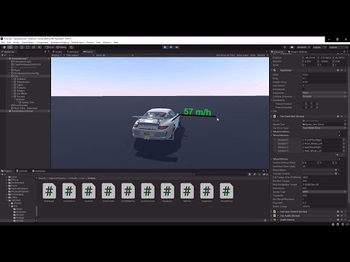](https://www.youtube.com/embed/uWorqkFSVjk?feature=oembed)